**Kinder Morgan, Inc.—Management Buyout**

Group 9

Q1: There are conflicts of interest in this LBO transaction.

1)There is a conflict between major shareholders (Kinder) and other shareholders. Investors may have more to gain in the long run by not accepting this offer.

2)There is a conflict between KMI (General Partner) and KMP (Limited Partner). By increasing the shareholder value of KMI by maximizing the value of its GP stake in KMP, the profit of LP might be influenced.

3) Initial conversations with Goldman & Sachs to increase shareholder value are held without board knowledge.

4) There is a conflict between Goldman& Sachs and shareholders since Goldman& Sachs act as the transaction consultant and investment side of the deal.

5) There is a conflict between management and other shareholders. The management team can see the undervalued GP stake and the expansion opportunities which other shareholders cannot see.

Q2: There is a mistake. Implied valuation of stand-alone general partners should include debt. The correct implied valuation of the stand-alone general partner is $6.9 billion to $4.6 billion.

Q3: No, we believe it is not a fair deal for shareholders of KMI. We would not vote to approve the transaction at $107.50/share.

1) There are too many conflicts of interest. It is really a bad sign of transaction.

2)We figured out the proper WACC is 6.3% so we choose the 7.5% discount rate scenario. The middle point is $111.2. Given that the MLP model just started and most people did not fully understand its business potential and tax benefit, the proper valuation should between $111.2 and $123.62. According to our own analysis, the proper valuation is $115.43.



Table 1 WACC calculation

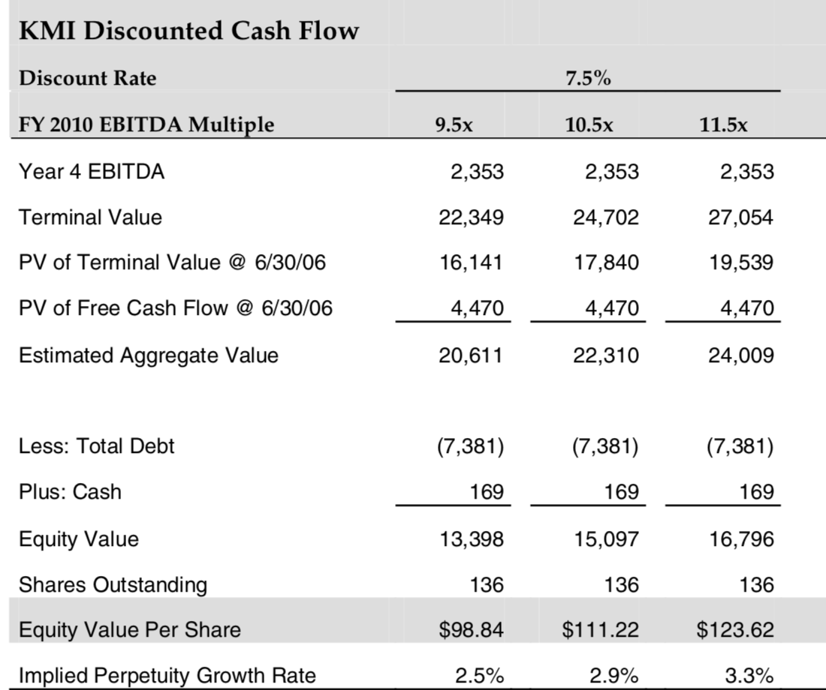

Table 2 7.5% discount rate scenario

Table 3 DCF Analysis